**Academic Writing**

Academic writing is not personal, complicated, and long-winded. It is also not journalistic, literary, and marketing text. It has its own set of rules and regulations. It is formal and unbiased, clear and precise, focused and well structured, well sourced, correct and consistent. Its main focus is to make the readers understand what they are reading with the formal, objective and concise language.

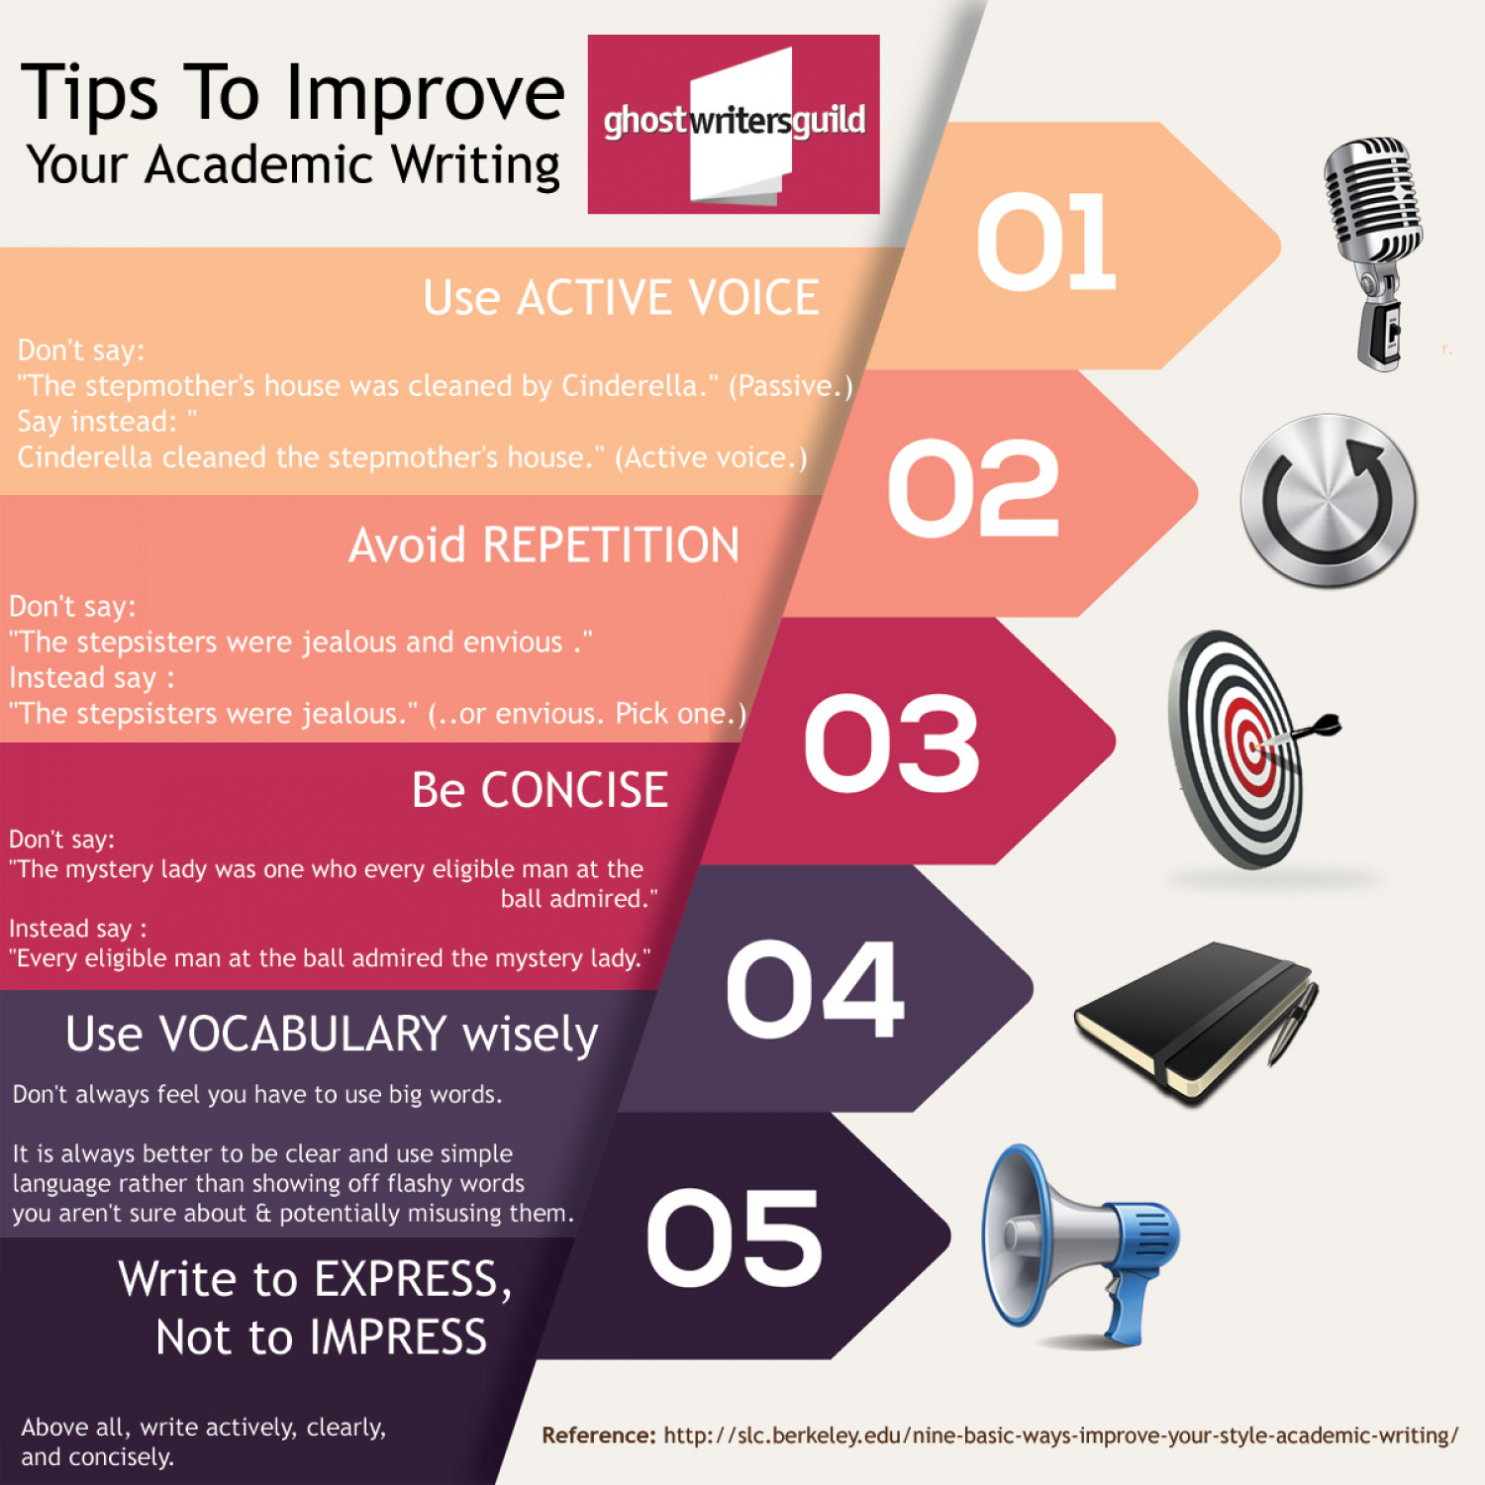

Figure 1: Academic Writing tips

Academic writing avoids vague language and stays being as specific as possible. The formal style used in academic writing ensures that research is presented consistently across different texts, so that studies can be objectively assessed and compared with another research. Specialist language or jargon is common and often necessary in academic writing, which generally targets an audience of other academics in related fields. Academic writing is always focused on an argument and presents ideas in a logical order. It always includes an introduction and a conclusion, divides longer texts into sections with clear headings. It starts a new paragraph when you move onto a new idea, uses a topic sentence at the start of each paragraph to indicate what it’s about, and make clear transitions between paragraphs. It uses transition words to express the connections between different ideas within and between sentences, appropriate punctuation to avoid sentence fragments or run-on sentences. Building arguments is the most important thing in academic writing because it late the readers to understand the topic, what the writer is thinking, what are the writer’s views and how the writer has engaged critically with the topic being discussed. The claims are always supported with evidences in an academic writing. The evidences will be written by other academics. It is really important to understand which evidences are appropriate to use in the academic writing. It is always important to cite the evidences in academic writing. It’s important to consistently apply stylistic conventions regarding writing numbers, introducing abbreviations, using verb tenses in different sections, capitalization of terms and headings, spelling and punctuation differences between UK and US English. That means we have to choose correct tense and voice.